WM_[For Thailand Only]How to Use the Logistics Inbound(GR) Process of the Thai
- T-Code/Function/Menu
Applications | Menu/Function/T-Code Name | Description
SAP-SD | ZSD77000 | Confirm inbound DN
SAP-WM | ZWM80440 | GR request Send
SAP-WM | ZWM80450 | GR complete
- Situation
  - Users who want to check how to use the logistics inbound process of the Thailand subsidiary
  - Inquiry Type
    - "I want to send the inbound delivery to the Thai subsidiary WMS."
    - "I want to confirm the GR confirmation process from the Thai subsidiary WMS."
    - "I want to check the inbound documents that need to be confirmed for the Thai subsidiary."

Logistics Inbound(GR) and WMS Interface Method
  - For logistics receipt requests, go to transaction code ZSD77000. Input the sales organization, shipping point/receipt point, condition values and execute.
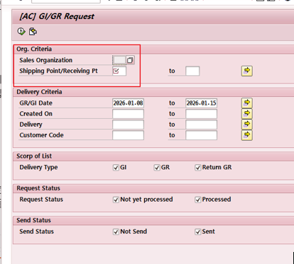
    - On the inquiry screen, Select All and click Request GI/GR to perform the shipment request.
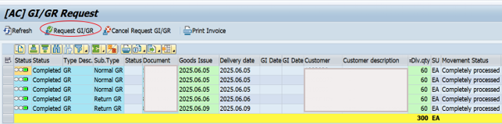
  - To send the outbound request to the WMS, go to the transaction code ZWM80440, input the plant, delivery date, and execute it.
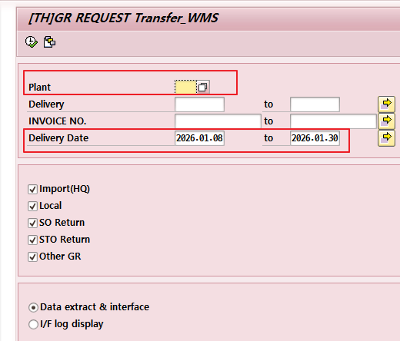
    - Select All on the Query Results screen – Click send in the upper left corner to send it to WMS.
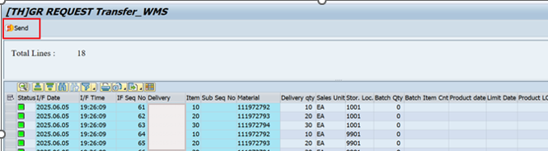
  - To confirm the receipt request, go to the transaction code ZWM80450, enter the condition values such as plant, I/F DATE, etc., and then look it up.
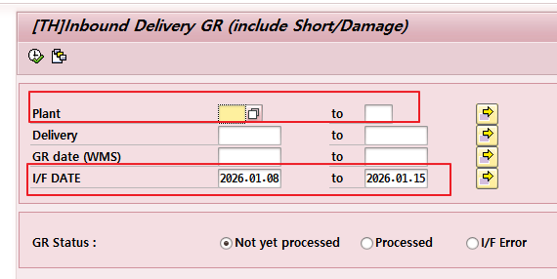
    - Select All on the inquiry result screen - Click "Confirm Movement" in the upper left corner to confirm the receipt request.
