FI_Carry Forward Manual_Year-end closing Asset Accounting (AJAB)
- T-Code/Function/Menu
Application | Menu/Func./Tcode | Descriptioin
SAP-FI | AJAB | Closes the Asset fiscal year for a company code.  Ensures no further postings can be made in the closed year.  Blocks postings in the old year.
SAP-FI | OAAR | How to check after Asset fiscal year closing
- Asset Year-end closing Procedure
  - Enter company code
  - Enter old fiscal year
  - If it is a test, check the "Test run" as 'X'
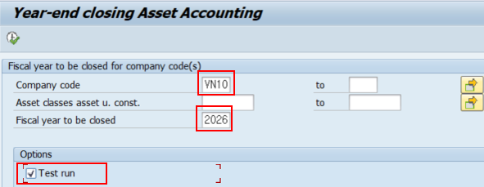

  - Delete the value of the "Test run" field, if it is a real run, Run in the background from the menu.
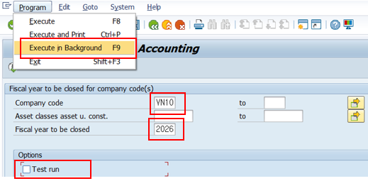

- Check Asset fiscal year closing in OAAR.
  - Choose “Company Code”
  - Choose “Fiscal Year”
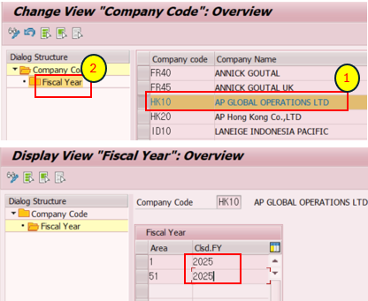
- The year 2025 when the asset closing was completed is entered

