FI_Carry Forward Manual_Receivables_Payables(AR_AP) carryforward (F.07)
- T-Code/Function/Menu
Application | Menu/Func./Tcode | Descriptioin
SAP-FI | F.07 | Carry forward the balance of Receivable/Payables to the next fiscal year
SAP-FI | FD10N  FK10N | How to check after Carry forward of AR/AP.
- Carry Forward Procedure for AR/AP
  - Enter company code
  - Enter new fiscal year
  - Check the “Select customers” box as 'X'
  - Check the “Select vendors” box as 'X'
  - If it is a test, check the "Test run" as 'X'
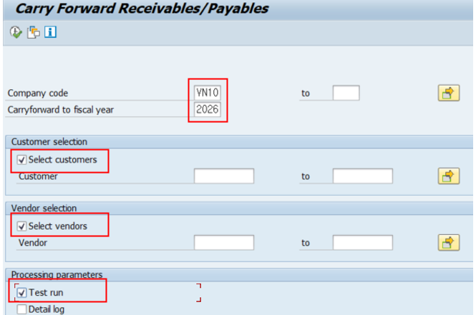
  - Delete the value of the "Test run" field, if it is a real run
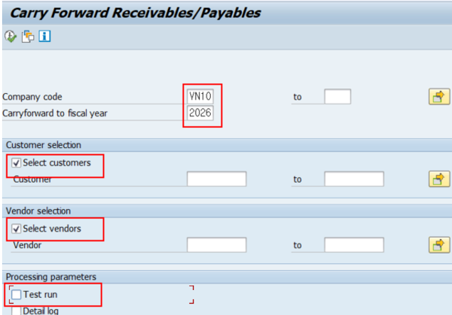

- After performing the AR (Customer) carryforward process, you can check whether everything was processed correctly in transaction FD10N.
  - Enter “Customer Code”
  - Enter “Company Code”
  - Enter “Fiscal Year”
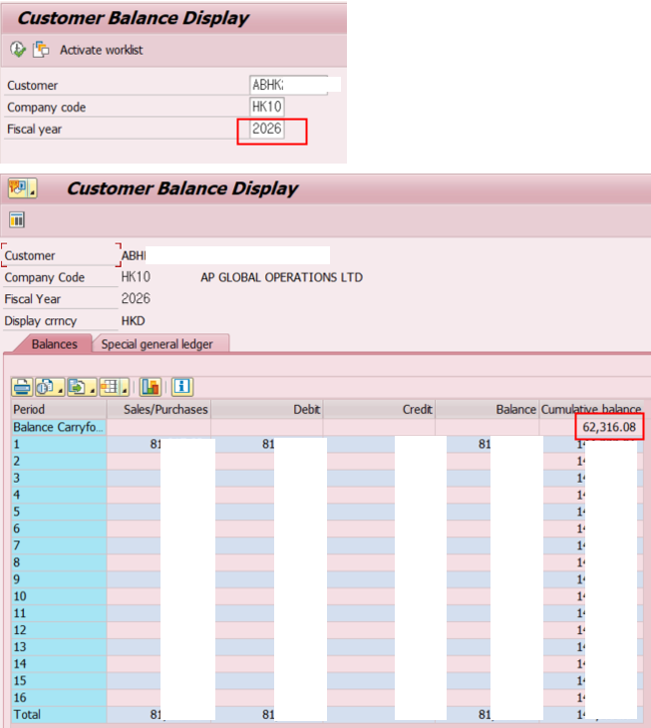
- The carryforward balance is the balance that is brought forward from the previous fiscal year into the current fiscal year.
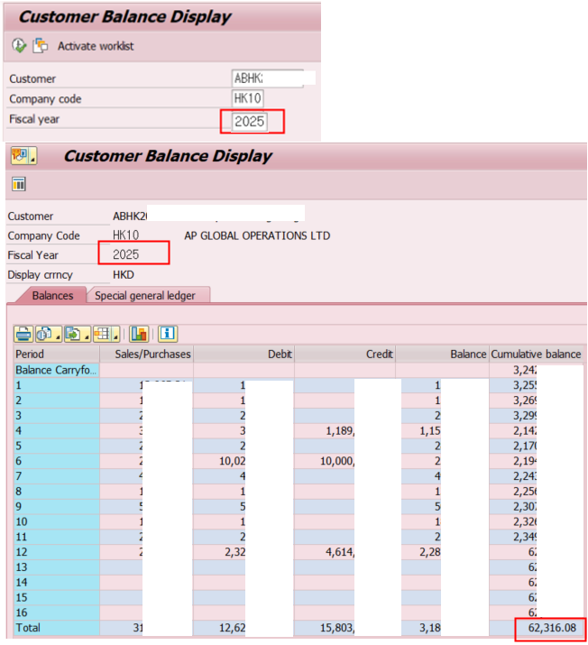
- You can verify that the year-end balance of 2025 matches the beginning balance (cumulative balance) of 2026. If they do not match, it means that additional postings were entered in the prior year after the carryforward process. In that case, simply rerun the carryforward process.

- After performing the AP (Vendor) carryforward process, you can verify that everything was completed correctly in transaction FK10N.
  - Enter “Vendor Code”
  - Enter “Company Code”
  - Enter “Fiscal Year”
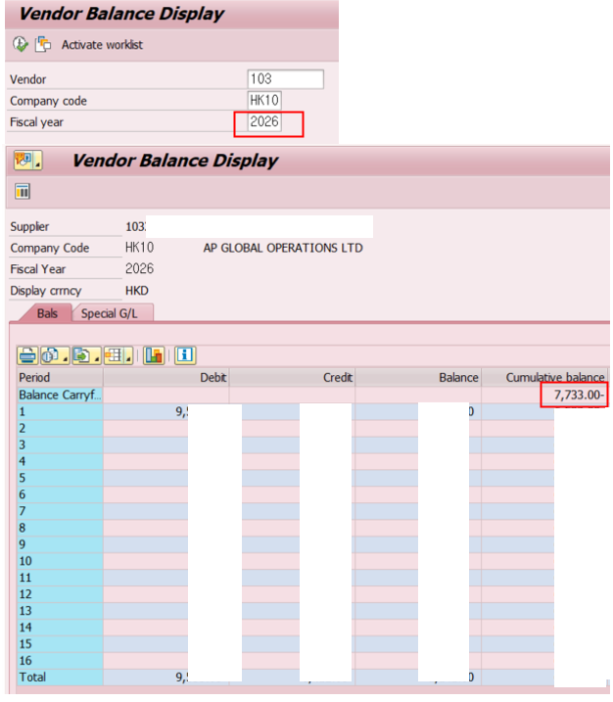
- The carryforward balance is the balance that is brought forward from the previous fiscal year into the current fiscal year.
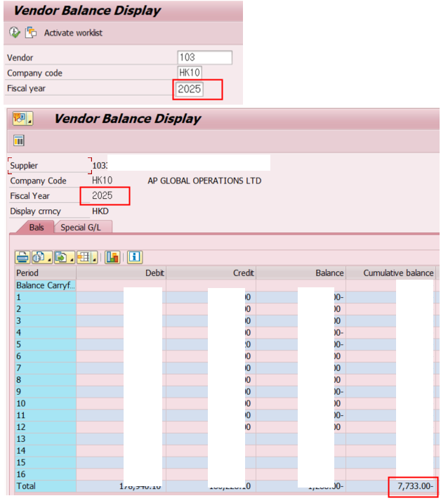
- You can verify that the year-end balance of 2025 matches the beginning balance (cumulative balance) of 2026. If they do not match, it means that additional postings were entered in the prior year after the carryforward process. In that case, simply rerun the carryforward process.

