FI-How to handle FI Doc. Reverse errors in ZFI03200 - No authorization to reverse documents approved by accounting dept.
- T-Code/ Function/Menu
Application | Menu/Func./Tcode | Description
SAP-FI | ZFI03200 | Explain how to take action on errors occurring in ZFI03200 that reverse process of FI documents.
- Error Message : No authorization to reverse documents approved by accounting dept.
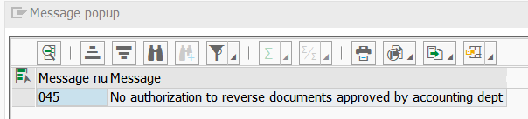
- Cause of error : The Financial Accounting Team approval document cannot be reversed.
- Resolution : If you ask the person in charge of the accounting team, the accounting team will check it and proceed with reverse.

