How to handle FI Doc. Reverse errors in ZFI03200 Error Message - Reverse is not possible, a payment order already exists.
- T-Code/ Function/Menu
Application | Menu/Func./Tcode | Description
SAP-FI | ZFI03200 | Explain how to take action on errors occurring in ZFI03200 that reverse process of FI documents.
- Error Message : Reverse is not possible, a payment order already exists.
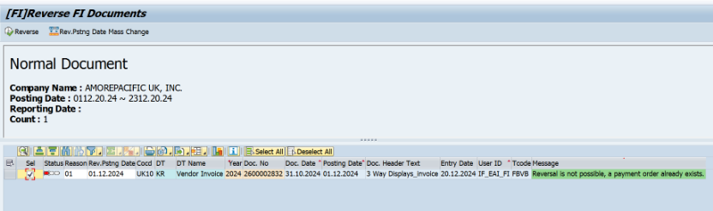
- Cause of error : This is an error message that occurred because the payment order for this document has already been created.
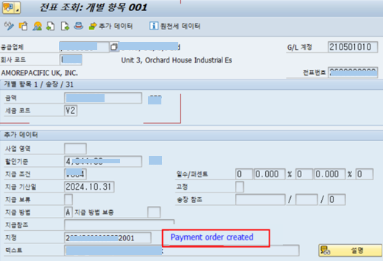
- Resolution : Please submit a request in IT Helpdesk > Data Modification > SAP-TR for payment order deletion. ITO SAP team will process it once received.

