SAP FI - How to handle FI Doc. Reverse errors in ZFI03200 - Doc. Type of S1(0100000000) cannot be reversed in this tcode.
- T-Code/ Function/Menu
Application | Menu/Func./Tcode | Description
SAP-FI | ZFI03200 | Explain how to take action on errors occurring in ZFI03200 that reverse process of FI documents.
- Error message : Doc. Type of S1(0100000000) cannot be reversed in this tcode. (T-code : ZFIT3010)
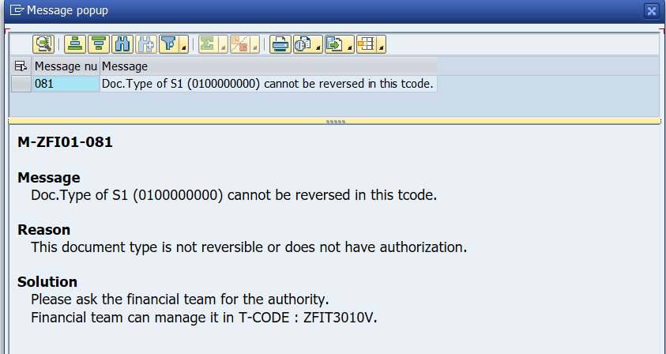
- Cause of error : The document type S1 is currently set to prevent reverse.
- Resolution : Please request the reversal from the Account team. The Accounting team change the setting to enable reverse of Doc. Type S1 in ZFIT3010V. 