How to handle FI Doc. Reverse errors in ZFI03200 - Document 6400003416 belongs to user OOOO. You don't have authorization to reverse.
- T-Code/ Function/Menu
Application | Menu/Func./Tcode | Description
SAP-FI | ZFI03200 | Explain how to take action on errors occurring in ZFI03200 that reverse process of FI documents.
- Error Message : Document 6400003416 belongs to user OOOO. You don't have authorization to reverse.
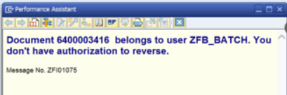

- Cause of error : This error is caused by a different SAP ID of document 6400003416 generator ID and the reverse dispensing handler.
- Resolutoin : Remove “Own Document Only” fields and run it.
