How to handle Auto. Payment errors in F110 : error message - No payment possible because items with a debit bal.still exist.
- T-Code/ Function/Menu
Application | Menu/Func./Tcode | Description
SAP-TR | F110 | Explain how to take action against errors that occur when executing F110 (Auto.Payment).
- Request Case: I got below Vendor (A) from F110, but -237.99 GBP amount was not reflected together.
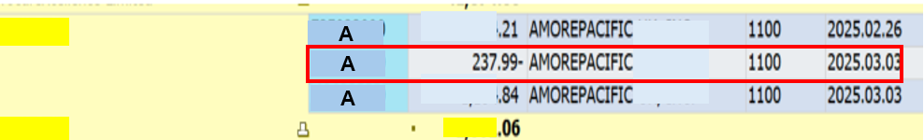
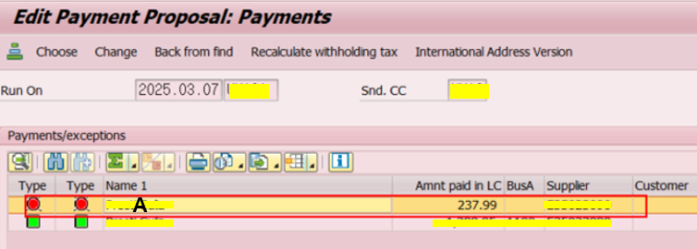
- Error Message: No payment possible because items with a debit bal.still exist.
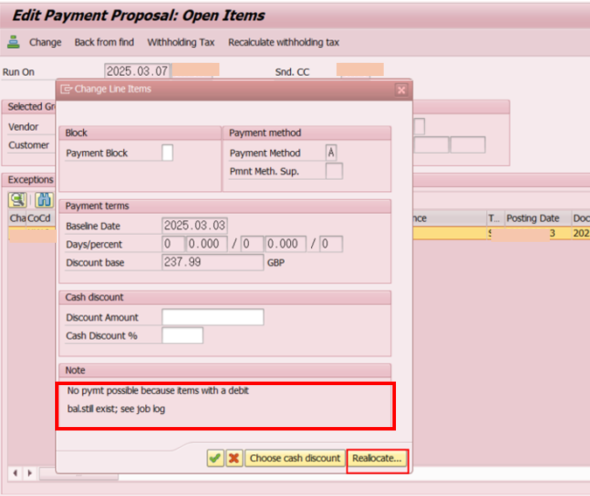

- Cause of error: If all three documents are the same House Bank, Account ID, there is no error, but if there are different Account IDs, there is an error.
- Resolution: Press "Reallocation" button to modify House Bank, Account ID(refer image in 3.)

