How to handle Vendor Master create/change errors in FK01/FK02 Error Message - Already exists master of same Tax Reg.No.(Vendor 1013672)
- T-Code/ Function/Menu
Application | Menu/Func./Tcode | Description
SAP-FI | FK01  FK02 | Explain how to take action against errors that occur when creating and changing of Vendor Master.
- Error Message : Already exists master of same Tax Reg.No.(Vendor 1013672)
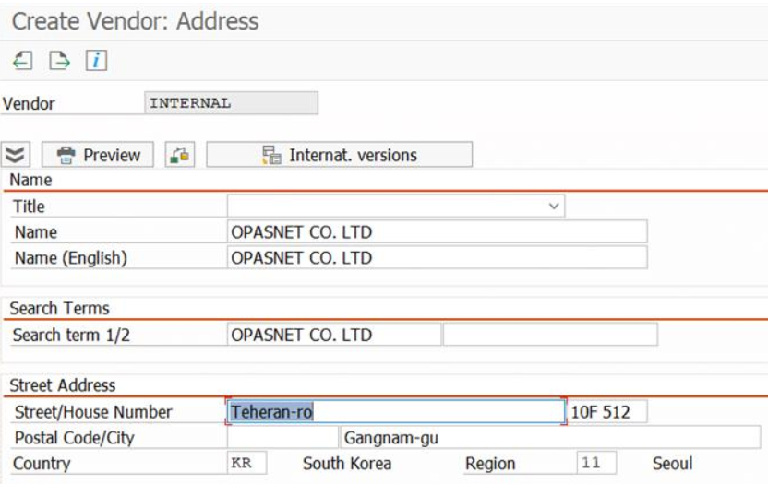
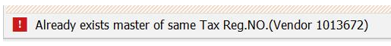
- Cause of error : If the account group is '1000' and the country code is 'KR', the value of the Tax Number field must be entered.
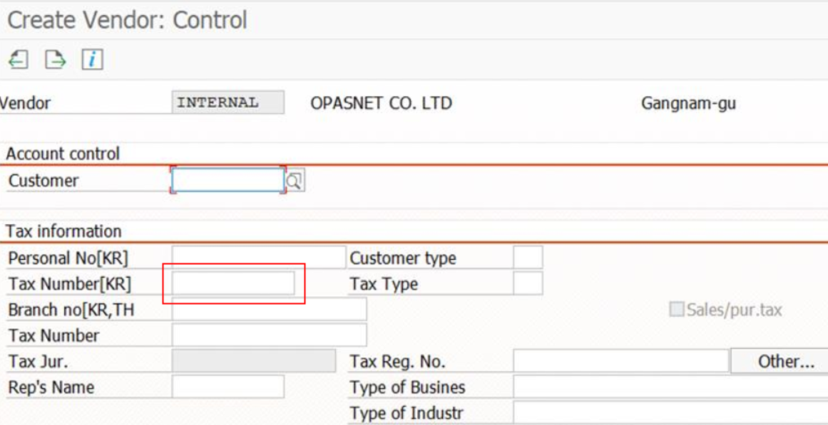
- Resolution : Enter a value for the Tax Number field.

