How to handle Auto. Payment errors in F110 : error message - No valid payment method found.
- T-Code/ Function/Menu
Application | Menu/Func./Tcode | Description
SAP-TR | F110 | Explain how to take action against errors that occur when executing F110 (Auto.Payment).
- How to handle error message - No valid payment method found.
  - Error Message : No valid payment method found.
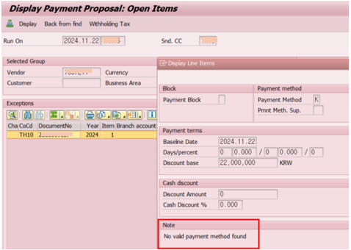
  - Casuse of error : The currency of the document is KRW, but it is an error caused by FBZP not setting KRW in the payment method K in the bank decision.
  - Resolution : Create a Vendor clearing doc. in FB05 or F-30.
