FI-How to handle Vendor Master create/change errors in FK01/FK02 : Error Message - You do not have authorization to change the payment block fields.
- T-Code/ Function/Menu
Application | Menu/Func./Tcode | Description
SAP-FI | FK01  FK02 | Explain how to take action against errors that occur when creating and changing of Vendor Master.
- Error Message : You do not have authorization to change the payment block fields.
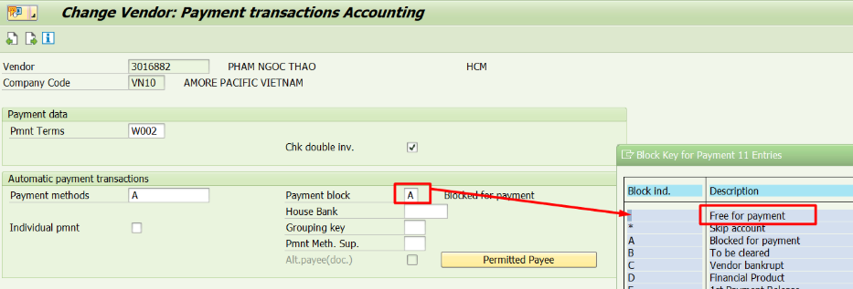
- Cause of error : You do not have authorization to change the payment block fields in FK02.
- Resolution : Please grant the permission to modify the payment block in ZFIT2120V.
