How to handle FI documents creation Error Message - Profit center CS0649 is locked in controlling area CN00.
- T-Code/ Function/Menu
Application | Menu/Func./Tcode | Description
SAP-FI | KE52  F-51 | Explain how to take action against errors that occur during FI documents generation.
- How to handle Error Message - Profit center CS0649 is locked in controlling area CN00.
  - Error Message : Profit center CS0649 is locked in controlling area CN00.

  - Cause of error : "Lock Indicator" was set in the Profit center CS0649, causing an error when generating the document.
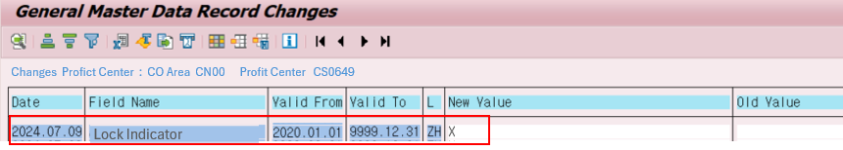
  - Resolution : Please remove the “Lock indicator”in SAP Tcode KE52 