How to handle FI documents creation Error Message - Create account 524503990 for 2025.04.10 as a cost element in controlling area SG00.
- T-Code/ Function/Menu
Application | Menu/Func./Tcode | Description
SAP-FI | KE52  F-51 | Explain how to take action against errors that occur during FI documents generation.
- Error Message: Create account 524503990 for 2025.04.10 as a cost element in controlling area SG00.
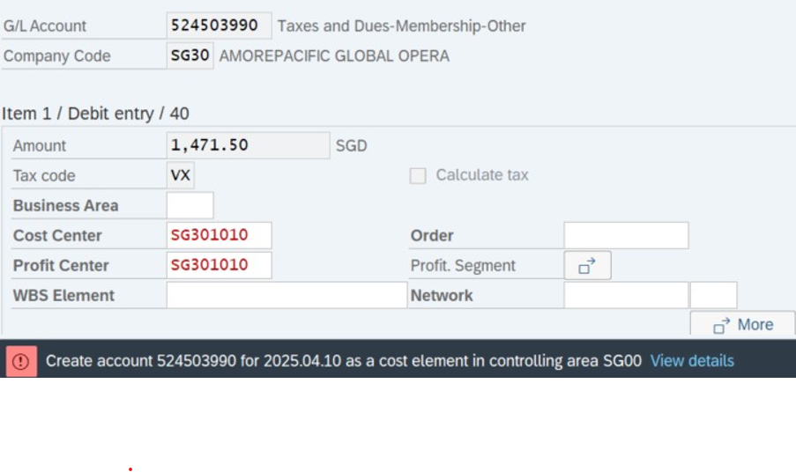
- Cause of error: An error occurred because the cost factor was not set for the new account 524503990.
- Resolution: Request the financial management team to create a cost element for the new account 524503990.
