No sales customers, create allocation criteria
- T-Code/ Function / Menus
Application | Menu/Function/T-code Name | Description
SAP-CO | ZCO22250 | Check No sales customers, create allocation criteria  No sales customers, create allocation criteria
- Executives and execution status
  - Executives – a person in charge of profit and loss of each corporation
  - execution status – Execute in the stage of no sales customer create allocating criteria in the controlling account closing stage

- The solution
  - T-CODE : ZCO22250 – Check No sales customers, create allocation criteria
    - Collect No sales Customer data option
- Controlling Area: Enter closing CO-Area (Required)
- Company Code: Optional (except for Hong Kong (HK00), where it must be entered because two company codes exist in one Controlling Area.)
- Month: Enter closing Year&Month (Required)
- Collect no sales customer data: Select Option
- Execute : Save after completion of allocation type selection.
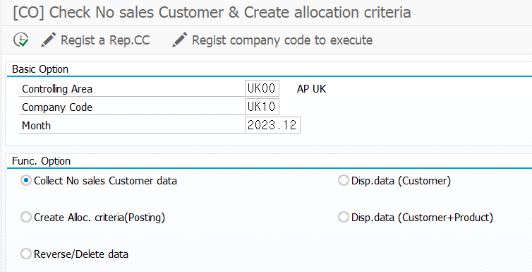
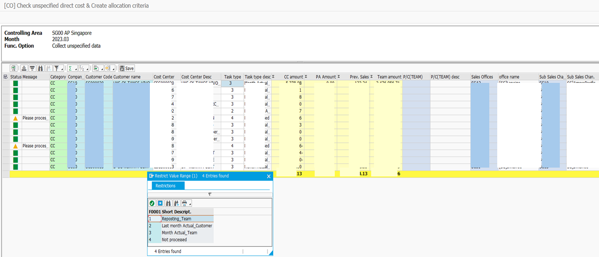

    - Create Alloc. Criteria(Posting)
- Controlling Area: Enter closing CO-Area (Required)
- Company Code: Optianal input. But HK00 must input
- Month: Enter closing Year&Month (Required)
- Create alloc. criteria: Select Option
- Execute : Post created allocation criteria
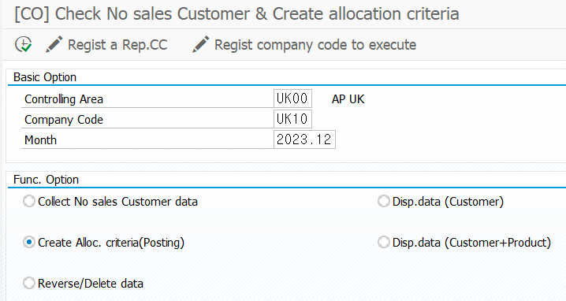
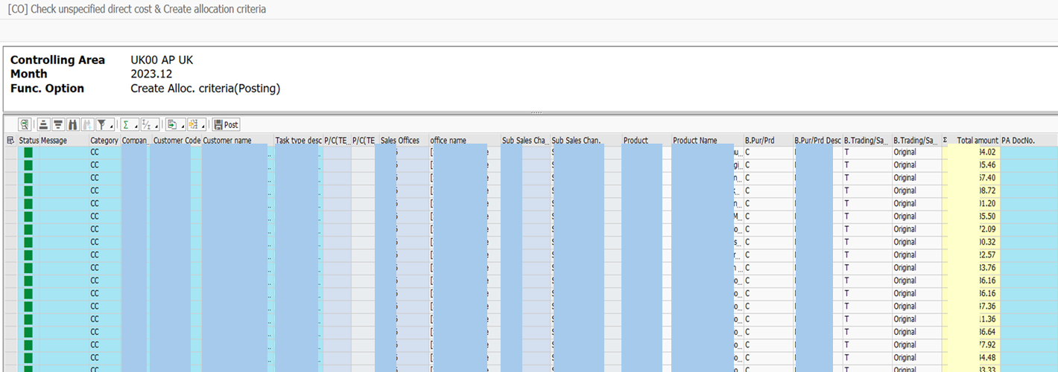

    - Reverse/Delete data
- If necessary, reverse the documents and delete data all.
- ※ After deletion, restart from step 3.1.1
