How to handle Bank Statement Differency in ZTR00770/ZTR00070.
- T-Code/ Function/Menu
Application | Menu/Func./Tcode | Description
SAP-FI | ZTR00770  ZTR00070  ZTR00200 | The bank statement aggregation (ZTR00200) program is executed every five minutes automatically.  but if the amount of Bank Statement Report (ZTR00700) and Monthly Bank Reconciliation Report (ZTR00070) do not match, Explain how to take action on Bank Statement Differency in ZTR00770/ZTR00070.
- There are two steps to match as follows. You can work on it sequentially.
- Step 1. Re-counting for the aggregation table
- Step 2. Save for the missing data.
(If the amount matches in Step 1, Step 2 is not required)
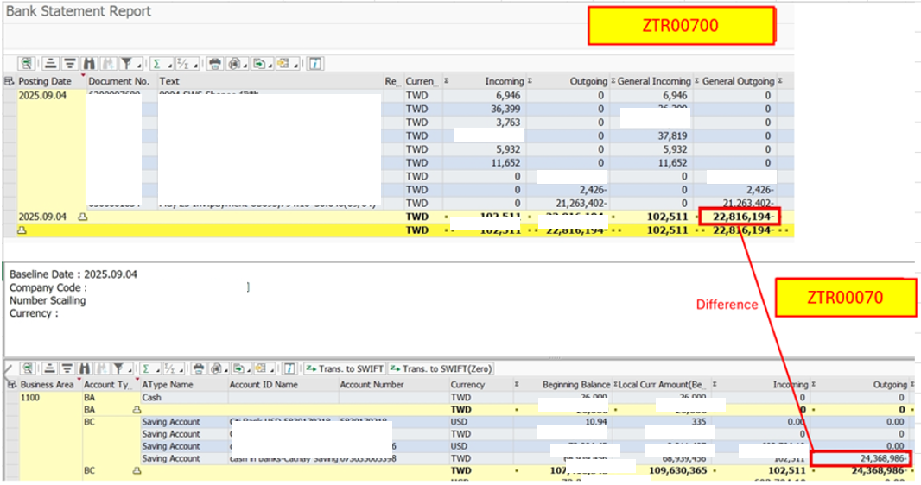
  - Step 1 : “Re-counting - Summary” for the aggregation table.
- There was a differency because the September 4th document was not aggregated in summary table.
- In this case, you should execute “Re-counting - Summary” with September 4th data in ZTR00200.
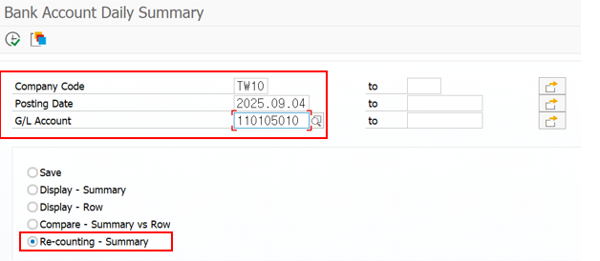
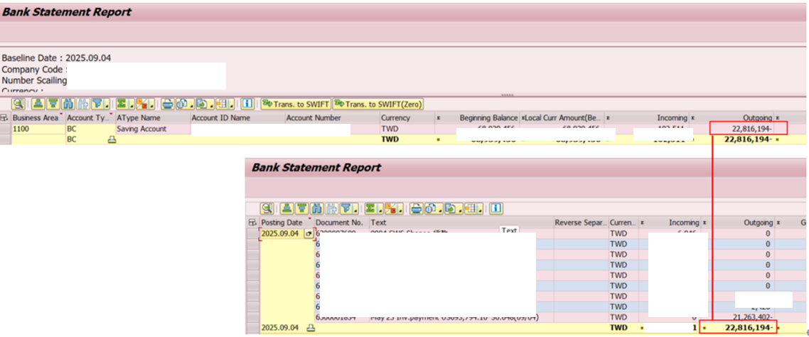
  - Step 2 : “Save” for the missing data.
- (If the amount matches in Step 1, Step 2 is not required)
- The bank statement aggregation (ZTR00200) program is executed every five minutes automatically. The last aggregation is 23:57. However, the documents created after 23:57 are missing.
- In this case, you should execute “Save” with September 4th in ZTR00200.
